SAS2021 Abstract template
Rachael Jack^{1,*}, Jonas Nölle¹, and Tobias Thejll-Madsen²

¹Department of Psychology, University of Glasgow
²Department of Computing Science, University of Glasgow

Summary In this section, please use 4-5 sentences to describe the gist of the study (no more than 400 characters). This will be included in the conference program should your submission be accepted. Lorem ipsum dolor sit amet, consectetur adipiscing elit. Praesent in sollicitudin urna, ac laoreet ante. Sed ut metus quis arcu porttitor volutpat. Donec vitae ornare nulla. Mauris volutpat sem metus, vitae rhoncus nulla hendrerit non. Pellentesque pretium orci ac venenatis lobortis.
Keywords · One · Two · Three · Four · Five
Name: email@domain.com

Introduction In this section, please use 4-5 sentences to introduce the theoretical background of your study. For in-text citations both single references (Fiske, 2020) or multiple references (Davidson, 1998; Jack, Garood, Yu, Caldara, Schyns, 2012) are possible. You can cite as many references as you are able to fit on the single page with the reference list included. A single figure can be placed in the document at a suitable position within a single column.
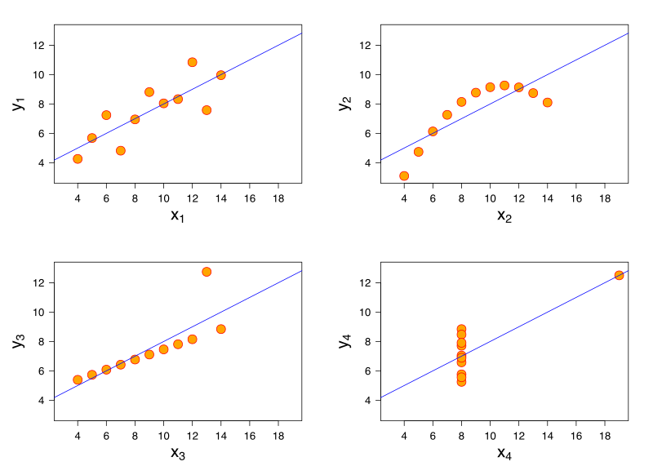
Figure 1: An example figure, which you can move to
where you see it fit

Aims In this section, please use 3-4 sentences to articulate the research question(s), hypothesis, and predictions (if applicable). Proin vitae fermentum enim. Proin sed dignissim neque, vel volutpat justo. In finibus mi mi, sed semper arcu mattis non. Quisque facilisis lectus at augue pretium, ut hendrerit quam porta. Aliquam congue, odio quis luctus imperdiet, tellus turpis consectetur enim, vitae finibus velit. Ut ultricies nunc sit amet dui consequat porttitor quis a magna.

Methods In this section, please provide sufficient details about the participants, materials, procedure and measurements of the study. We recommend 6 sentences for this section.Proin rhoncus dignissim finibus. Mauris enim ante, dictum at orci at, venenatis finibus mauris. Interdum et malesuada fames ac ante ipsum primis in faucibus. Praesent ornare odio quis faucibus vulputate. In mollis lacus non tellus lacinia pellentesque. Vestibulum porta massa euismod suscipit scelerisque. Aenean dictum convallis ultricies. Cras id sodales orci, in egestas justo. Nam sodales justo at lectus lacinia, non porttitor nisl scelerisque. Phasellus tincidunt tellus libero, quis rhoncus dolor feugiat at.

Results In this section, please use about 6 sentences to describe the analysis and results (for New Results submission) or the analysis plan and predicted results. The unused alternative titles for this section can be deleted. Formulas can be included as follows:
$$P\left(θ | D\right)=P\left(θ\right) \frac{P(D|θ)}{P(D)}$$ | (1)
In-line math in LateX is accomplished by wrapping text in "\$", so \$4 + 4 = 8\$ would become $4+4 = 8$ Praesent felis ligula, vehicula eu venenatis sed, fringilla eu ipsum. Phasellus at nunc luctus, sagittis arcu maximus, tincidunt leo. Vestibulum venenatis luctus velit, ac dictum ipsum ullamcorper eu. Ut ultricies nunc sit amet dui consequat porttitor quis a magna.

Conclusions In this section, please use about 3 sentences to articulate the conclusion of this study. Etiam vitae molestie ex. Cras in ligula vulputate, semper urna eu, vehicula sapien. Nulla in dui tempus, porta mi in, dapibus sapien. Sed viverra luctus orci, eu ornare nisl varius vel. Suspendisse molestie vel nisi et interdum.

Acknowledgements For acknowledgements, make sure to not reveal your identity in the anonymous version of the PDF.

References
Davidson, R. J. (1998, May). Affective Style and Affective Disorders: Perspectives from Affective Neuroscience. Cognition and Emotion, 12(3), 307–330. doi: 10.1080/026999398379628
Fiske, A. P. (2020, January). The lexical fallacy in emotion research: Mistaking vernacular words for psychological entities. Psychological Review, 127(1), 95–113. doi: 10.1037/rev0000174
Jack, R. E., Garrod, O. G. B., Yu, H., Caldara, R., & Schyns, P. G. (2012, May). Facial expressions of emotion are not culturally universal. Proceedings of the National Academy of Sciences, 109(19), 7241–7244. doi: 10.1073/pnas.1200155109

